66390 - LED9DA19/827
GE Energy Smart® A19
• Energy-efficient LED lamps. Long life. Omnidirectional.
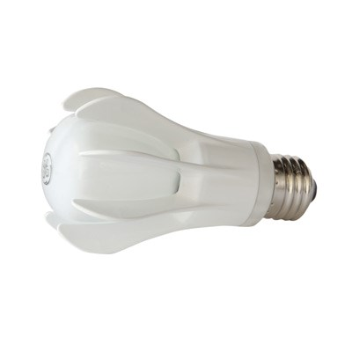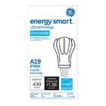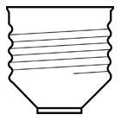
Aug 11, 2013 7:34:18 PM
GENERAL CHARACTERISTICS
Lamp Type | Replacement Lamps - A-line
Bulb | A19
Base | Medium Screw (E26)
Additional Info | GE Life Rating is based on 70% Lumen Maintenance
Bulb Shape | A-19
Color | White
Dimming Capability | Operates on dimming circuits. See GELighting.com/dimming for further information
Equivalent Wattage | 40.0 W
Lamp Type | A-19
Life in Years | 22.8
Rated Life | 25000.0 hrs
PHOTOMETRIC CHARACTERISTICS
Color Rendering Index 82.0
(CRI)
Color Temperature 2700.0 K
Initial Lumens 450.0
Nominal Initial Lumens per 50.0 Watt
ELECTRICAL CHARACTERISTICS
Voltage 120.0 Wattage 9.0
DIMENSIONS
Bulb Diameter (DIA) 2.375 in(60.3 mm)
Maximum Overall Length 4.4300 in(112.5 mm) (MOL)
PRODUCT INFORMATION
Product Code | 66390
Description | LED9DA19/827
Standard Package | Case
Standard Package GTIN | 10043168663905
Standard Package Quantity | 6
Sales Unit | Unit
No Of Items Per Sales Unit | 1
UPC | 043168663908

