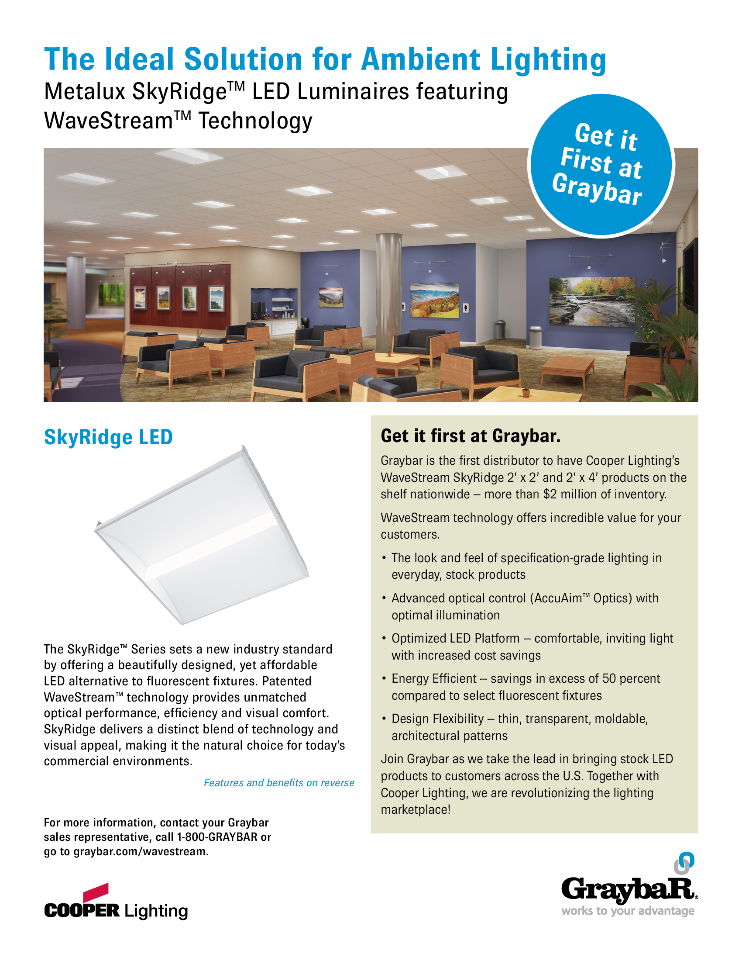

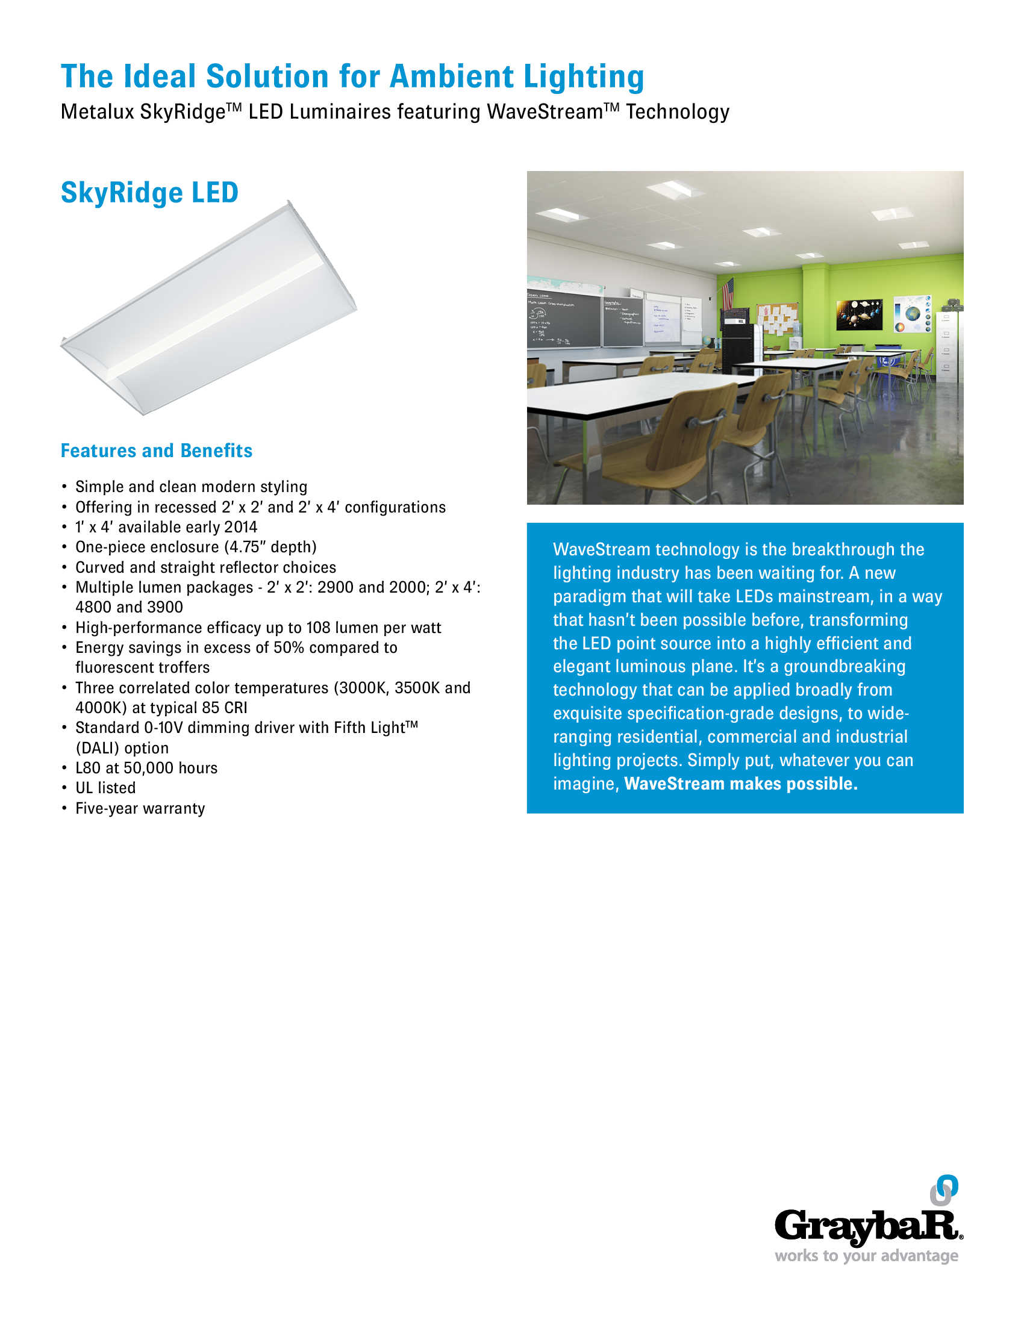

Catalog Number | Description | Price | GBID | Weight (Ea) | Pallet (Qty)
SkyRidge Series
24SR-LD1-39-C-UNV-L835-CD1-U | 2x4, 3900 Lumens, Curved, UNV, 3500K, 0-10V |  | 25564376 | 24 lbs. | 8
24SR-LD1-39-C-UNV-L840-CD1-U | 2x4, 3900 Lumens, Curved, UNV, 4000K, 0-10V |  | 25564377 | 24 lbs. | 8
24SR-LD1-48-C-UNV-L835-CD1-U | 2x4, 4800 Lumens, Curved, UNV, 3500K, 0-10V |  | 25564378 | 24 lbs. | 8
24SR-LD1-48-C-UNV-L840-CD1-U | 2x4, 4800 Lumens, Curved, UNV, 4000K, 0-10V |  | 25564379 | 24 lbs. | 8
22SR-LD1-20-C-UNV-L835-CD1-U | 2x2, 2000 Lumens, Curved, UNV, 3500K, 0-10V |  | 25564380 | 12 lbs. | 16
22SR-LD1-20-C-UNV-L840-CD1-U | 2x2, 2000 Lumens, Curved, UNV, 4000K, 0-10V |  | 25564381 | 12 lbs. | 16
22SR-LD1-29-C-UNV-L835-CD1-U | 2x2, 2900 Lumens, Curved, UNV, 3500K, 0-10V |  | 25564382 | 12 lbs. | 16
22SR-LD1-29-C-UNV-L840-CD1-U | 2x2, 2900 Lumens, Curved, UNV, 4000K, 0-10V |  | 25564383 | 12 lbs. | 16

